Doncaster Town Centre Street Entertainment Policy

What is Street Entertainment?

Street Entertainment is a broad term used to define performance in a public space, it could be a musical performance, dance act, theatrical enactment or painting. As a rule of thumb, if you are performing in a public space you are performing Street Entertainment.
Why do we need a policy?
Doncaster Town Centre is a busy destination shared between those who live, work, trade and simply enjoy their free time in the public space. Such a diverse group in a confined area could lead to conflict, we feel that a fair to all policy will allow the area to thrive.
It is of benefit to all Town Centre users to create a bustling and vibrant atmosphere, through open dialogue and a set of guidelines we feel that this can be achieved. This policy will set out what is deemed fair use of public space and focus on compromise and co-operation between all parties – allowing Street Entertainers to entertain and businesses to operate.
In the past there has been a division between Street Entertainers and businesses, with no party wholly innocent. Complaints have often been due to the volume of performance, obstruction of doorways / fire escapes and repetitive performances. Of course, some complaints have been due to the intolerance of businesses or a personal dislike of the entertainment being performed. This policy will form a fair balance for all users of the area.
Behind this policy there is the potential for legal enforcement, in the vast majority of cases this should not be needed and conflict will be resolved via compromise.
The guidelines set out within this policy have been made in partnership with Doncaster Council, South Yorkshire Police and the ‘Keep Streets Live’ campaign group.
Can I perform in Doncaster Town Centre?
Yes! We strongly encourage it. This policy should be considered a guidance document. If you have further questions after reading please contact towncentremanagement@doncaster.gov.uk and the team will be happy to help.
We are not able to allow street entertainment from performers under the age of 14, we also recommend those under the age of 16 to be accompanied.

Where can I perform?
You can perform legally on any Public Highway in Doncaster provided you follow this guide and do not cause an obstruction. However, you are likely to find the areas below most suitable:
St Sepulchre Gate – A wide pedestrianised retail area. Although pedestrianised, emergency vehicle access is always required so please do not perform on the paved road area. St Sepulchre Gate is also home to several banks and opticians, try to avoid these areas as they have noise sensitive operations inside. Instead try performing near the cafes and coffee shops with outside dining areas or the open space areas.
Baxter Gate – Another busy retail area, you may find there is too much pedestrian activity to safely perform but there are several cafes and wider pavement areas.
Sir Nigel Gresley Square – A large open space and home to the CAST theatre, Savoy Cinema and restaurants. In summer there are plenty of office workers sitting in the area eating lunch,
Train Station Forecourt – Recently regenerated, the Train Station forecourt reopened in 2020 and has fountains, seating and grassed areas.
Hall Gate & Silver Street –These streets are Doncaster’s nightlife hub and could suit performances on an evening or weekend. Make sure to be extra vigilant with equipment if performing at night time.
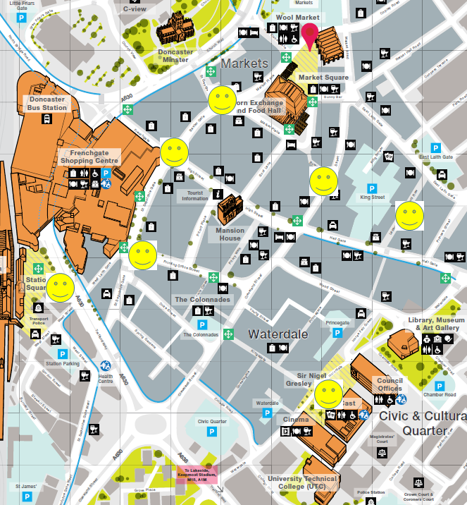

I’ve picked a spot, what next?
After finding a suitable location to perform, it is encouraged to introduce yourself to those in the area. Pop into the nearby businesses and let them know you will be performing outside or ask the people in an outside dining area if they have any requests. You may consider yourself the next Ed Sheeran but if the people around prefer Iron Maiden there could be a problem. Having a quick chat beforehand can solve conflict before it arises.
Another factor to consider is setting up too close to another performer, not all musical styles harmonise. Move a reasonable distance away to perform or ask if they will be moving on soon. If they aren’t finishing their set soon, find a new location, 100 paces apart will most likely avoid performances conflicting with each other. Constructively communicating is key, it could even lead to a Bradley Cooper and Lady Gaga style duet!
Whilst your musical performance may be fresh and interesting to shoppers passing by, remember that the businesses close to you will hear your repertoire all the time you play. For this reason we suggest a performance does not last for more than an hour at any single location, after which you should move on to a spot at least 100 paces away.
As the Town Centre is a busy place, make sure that where you set up does not cause an obstruction or block the free flow of pedestrians, cause them to have to step into areas of traffic nor restrict access into businesses
Remember that all Town Centre users have the same right to enjoy the public space as you do, compromising on performance length, volume or location will likely lead to a better atmosphere for all. When talking, remain courteous. Often the tone of a conversation decides its outcome, keeping a civil and polite Town Centre street scene is to everyone’s benefit.
How loud can I be?
There is no way to give a precise measurement on acceptable volume but as a rule, your level should be just above the general level of ambient street noise but not intrusively so. Doncaster Town Centre is made up of many sounds whether it be traffic, crowd noise, market traders selling fruit & veg or other sources. Some of these may be louder or quieter than your performance but be mindful of increasing your volume to drown ambient noises out. Performance volume should never be clearly audible inside nearby businesses. Do not perform close to sensitive businesses such as banks and opticians, and remember, consider the effect caused every time a customer goes into a business, when the door opens, and increased volume of music enters
The Town Centre’s architecture can have an unintended effect acoustically carrying music further or distorting sound if it is too high or bass driven, especially large hard surfaces and the Frenchgate centre overhangs, which can unintentionally reflect and focus sound behind the performer.
When choosing to perform in Doncaster Town Centre think carefully about the equipment you will be using. A 5-piece drum kit and PA system will sound great headlining Wembley arena but will likely cause problems in a busy Town Centre such as Doncaster. Many instruments can have small modifications to make them friendlier to the location. Brass instruments can have dampers or mutes and drums can be played with brushes. Being considerate with your choice of equipment will likely lead to crowds being more considerate at the end of the performance.
If you are using amplification and speakers, position them carefully to avoid directing sound towards businesses, especially their entrance doors, and if you are intending reflecting sound off any such surfaces, be aware of unintended “sound hotspots” caused by this
Safety
It goes without saying that your performance should be carried out in a way that does not put yourself or members of the public at risk. Make sure that any speakers etc are stable and cannot fall or be knocked over by passers-by, don’t have trailing cables that could be tripped over, and if you are doing anything more unusual, such as using fire, petrol generators or juggling/throwing items, seek professional advice and guidance and complete a risk assessment first. You are highly recommended to take out public liability insurance in case anything does go badly wrong
Global health pandemics and street entertainment don’t typically go hand in hand. The Keep Streets Live campaign have provided suggestions on how you can keep yourself safe and your audience.
Cashless payments - Have a contactless payment option available such as a card reader, QR Code, or display a PayPal link.
Collecting cash - Collect your cash in a sealable container so you do not need to handle it. Disinfect it when you get home.
Wash your hands - Wash your hands thoroughly after handling your equipment, your money, before eating, after driving, etc. Carry hand sanitiser as access to public washrooms may be limited.
Pitch selection - Social distancing may make choosing your pitch more complicated. You need to leave space between yourself and your donors, and you need to make sure others can also pass by safely. When choosing your pitch be aware of where customers may need to queue to enter businesses.
Equipment - You may need to move locations due to changes in pedestrian flow in order to maintain social distancing, so it is worth considering becoming as lightweight as possible. Do not share equipment with other buskers or allow members of the public to touch it.
Crowd management - It is your responsibility to manage your crowd. Ask your audience to disperse, respect each other’s space etc. as is necessary according to the current guidance.
The law - Familiarise yourself with the latest legislation and guidance on working outside, gatherings and social distancing at www.gov.uk/coronavirus
Can I sell CDs or merchandise?
No as this is classed as street trading and is prohibited in Doncaster Town Centre. Receiving contributions for a performance is acceptable as they are made by the public on a voluntary basis.
If you do wish to have CDs or merchandise available, they can either be given free of charge or clearly sign posted as being available on a voluntary basis. We suggest a sign wording such as “To comply with street trading legislation, these CDs (or other product) are not being offered for sale, any contribution you make is voluntary and at your discretion. Suggested contribution £x”.
To further comply with the street trading legislation, the provision of goods must be a clear secondary aspect of the performance. It is also important to note that random audits may be carried out by authorities. Make sure to not be infringing copyrighted materials.
Can I collect money for Charity?
It is illegal to collect money or sell articles for the benefit of charitable or other purposes without obtaining a street collection licence from the Council if that collection is held in a street or public place.
To obtain this licence, go to www.doncaster.gov.uk and search for ‘Street Collection Licence’
Resolving Issues
For businesses, making a formal complaint about a street entertainer should not be the first step. Engage in civil communication with the performer and attempt to resolve via compromise, we imagine that the vast majority of issues can be fixed in this manner.
If a resolution cannot be found, please contact the Town Centre Engagement Officers at Towncentremanagement@doncaster.gov.uk or report via 01302 736000. The Officers will assess the situation and take the appropriate action.
For performers, it is important to try and resolve issues in a civil manner. Moving further along the street, reposition or reduce the volume of any amplification or taking a short break will likely satisfy all parties and should be the first actions taken.
If a resolution cannot be found, please contact the Town Centre Engagement Officers at Towncentremanagement@doncaster.gov.uk or via 01302 736000. The Officers will assess the situation and take the appropriate action.

Keep Streets Live
Along with Doncaster based partners, we are proud to say that this policy has been written with the help of the Keep Streets Live campaign
The Keep Streets Live campaign exists to protect public spaces for informal offerings of music and the arts. We also concern ourselves with other threats to public space which marginalise vulnerable groups and jeopardise freedom of expression and assembly. We believe that dialogue, common sense and Common Law are more desirable and effective tools than arbitrary blanket regulation.
If you feel that enforcement action has been wrongly taken against you, please contact contact@keepstreetslive.com
Enforcement
The following flowchart is the course of action followed upon receiving a complaint.
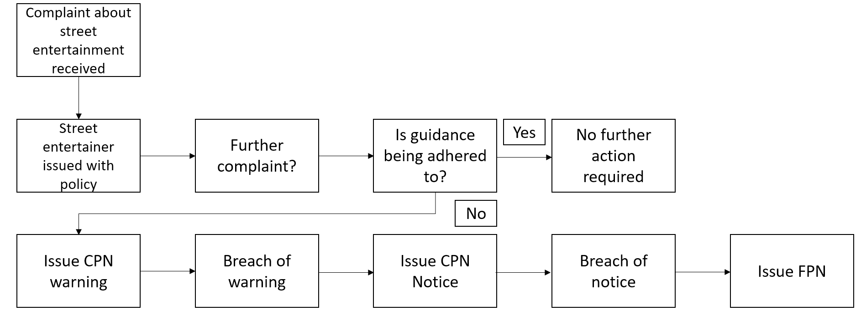
CPN – Community Protection Notices are valid for 6 months
FPN – Fixed Penalty Notices with the potential for prosecution through Magistrates Court
Street Entertainment is covered by several pieces of legislation:
Environmental Protection Act 1990 – where a statutory nuisance is being caused, noise abatement notices can be served. Breaching these notices can lead to fines or the seizure of equipment.
Control of Pollution Act 1974 – Section 62 states that no amplification is allowed on a public street after 2100 and before 0800.
Anti-Social Behaviour Crime and Policing Act 2014 allows Doncaster Council and the Police to act against behaviour that is detrimental to the community, if genuine and serious antisocial behaviour is taking place a Community Protection Notice may be served.
1980 Highways Act – States that obstruction of the Public Highway is an offence.

